Management of Extensor Tendon Injuries

Zone 1 (mallet) extensor tendon repairs

Closed injury:

- Immobilise DIPJ only in neutral / slight hyperextension for 6-8 weeks in thermoplastic gutter splint

Open injury:

- With surgical repair, the DIPJ may be k-wired in extension.
- K-wire removal will be at 6–8 weeks (be guided by op note).
- Splint the DIPJ in extension for 8 weeks whether a k-wire has been used or not.

Physiotherapy:

- The patient should attend once a week to check the splint / skin condition. When changing the splint care must be taken to support the DIPJ and not allow any joint flexion – see image below
- Following removal of splint / K-wire, commence active exercises and light function but no passive DIPJ flexion
- If an extensor lag develops discuss options with Senior
- Do not use blocking exercises immediately to regain DIPJ flexion, use hook fist to allow relaxation of the lateral bands and therefore less strain through the repair site
- With all mallet injuries the MCPJ and PIPJ should be mobilised throughout

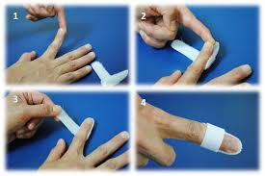

Zone 3 (central slip) extensor tendon repairs

There are 2 options for rehabilitation of extensor tendons in this zone:
- Immobilisation protocols
- Early active protocol (SAM – short arc motion)

1. Immobilisation protocols

Acute closed central slip rupture:
- Immobilise PIPJ at 0 degrees for 6 weeks with a thermoplastic gutter splint / Boutonniere splint. The DIPJ can be mobilised

Surgically repaired central slip repair with intact lateral bands:

Immobilise PIPJ at 0 degrees for 6 weeks with a thermoplastic gutter splint.
- The DIPJ can be mobilised whether there is an open or closed central slip injury.
- However, it is difficult to get enough stability within the splint if just the PIPJ is immobilised.
- Therefore we usually splint both IPJ’s in a gutter splint at rest and either exercise the DIPJ during physiotherapy treatment session only (if the patient doesn’t appear to be compliant) or teach hourly removal of splint and perform DIPJ exercises whilst maintaining the PIPJ in extension if the patient is sensible.

Surgically repaired central slip repair and lateral bands:
- Immobilise PIPJ & DIPJ at 0 degrees for 6 weeks with a thermoplastic gutter splint.
- Commence intermittent active DIPJ exercise at 3 weeks to promote tendon glide

Commencement of PIPJ motion at 6 weeks
  - Aim to achieve no more than 30 degrees PIPJ active flexion in the first week of exercise.
  - Concentrate on active PIPJ extension
  - If there is no extensor lag after the first week of exercise, gradually increase range of flexion
  - If extensor lag persists consider splinting

2. Early active motion protocol (SAM – short arc motion):

Criteria for use of early active motion:
- Compliant patient
- Complicated injury (joint capsule open) or stable fractures i.e. heightened risk of adherence / loss of motion
- Can commence this regime immediately post-op or after 2-3 weeks of immobilisation – discuss with Senior / Surgeon

Protocol:

Exercise | Splint
Resting gutter splint with PIPJ & DIPJ at 0 degrees between exercise sessions | Resting gutter splint  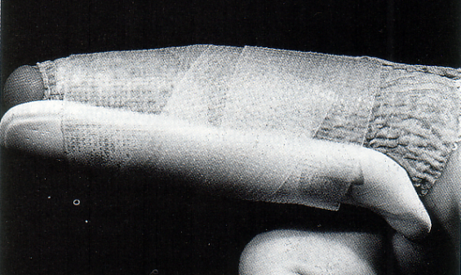
Remove resting gutter splint every hour for exercise  Apply volar static flexion blocking splint (1) with PIPJ limited to 30 degrees and DIPJ limited to 25 degrees  Wrist positioned at 30 degrees flexion and MCPJ at 0 degrees extension  Active flexions (reps to be individually tailored) to the splint and back to 0 degrees extension | Splint 1  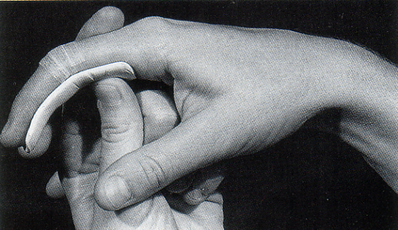  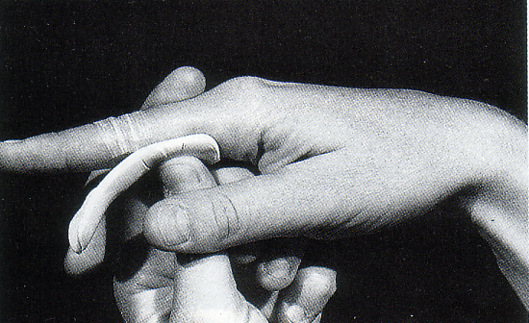
Volar static flexion blocking splint (2) with PIPJ at 0 degrees and DIPJ either free to move into full flexion if lateral bands are uninjured or DIPJ limited to 30 – 35 degrees flexion if lateral bands repaired  Active flexions (reps to be individually tailored) to the splint and back to 0 degrees extension | Splint 2  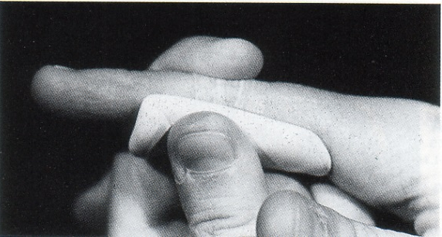  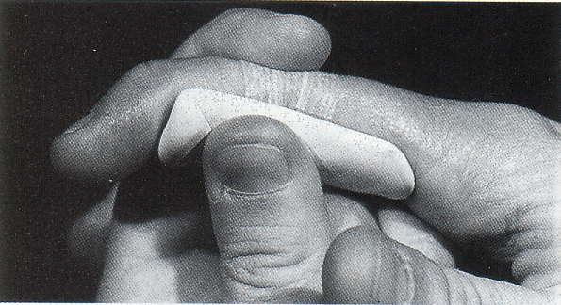
At weekly intervals, splint 1 altered to allow 40 degrees PIPJ flexion if no evidence of extensor lag.

Increased to 50 degrees at week 3 and 70 – 80 degrees by the end of week 4

Week 5 commence active composite flexion exercises

References
Evans RB, (1995) An update on extensor tendon management, In Hunter JM, Mackin EJ, Callahan AD, Rehabilitation of the hand: Surgery and Therapy, 4th edition, Mosby, St Louis

Zone 5 - 7 extensor tendon repairs

- immobilised for 3 weeks
- in volar slab with approximately 30 wrist extension and 30 MCP flexion
- at 3 weeks active hourly exercise and light function
- no passive flexion until 6 - 8 weeks
- no driving for 4-6 weeks
- no heavy use/sports for 8-12 weeks

Complications:
- extensor lag
- adhesions

If complicated by metacarpal fractures or skin grafting, adapt to an early active regime (with either a dynamic splint or static volar splint) to encourage tendon gliding. Discuss with the operating surgeon, consultant and senior

Extensor pollicis longus repairs

Zone 1: treat like a mallet finger

Other zones:

- immobilised for 3 weeks
- in volar slab with slight wrist extension and thumb extension at all joints
- fingers free to exercise actively but limit function
- after immobilisation period move to active exercise hourly
- no passive flexion until 6 - 8 weeks
- no driving for 4-6 weeks
- no heavy use/sports for 8-12 weeks

